**Project Design Phase-I**

**Solution Architecture**

|  |  |
| --- | --- |
| **Date** | **19 October 2022** |
| **Team ID** | **PNT2022TMID28767** |
| **Project Name** | **IoT Enabled Smart Farming Application** |
| **Maximum Marks** | **4 Marks** |

**Solution Architecture:**

The main goal of this Smart Farming is to optimize the harvesting land per unit by using modern methods to achieve best in terms of quality, quantity and financial return. The term smart farming is also known as Precision Farming which uses a wide range of technologies, including GPS services, sensors and etc. These technologies are very much required in agriculture sector includes with climate forecasting, robotics, science based solutions, environmental controls and etc. An M2M system is necessary to analyse the data and initiates the responses to the information received.

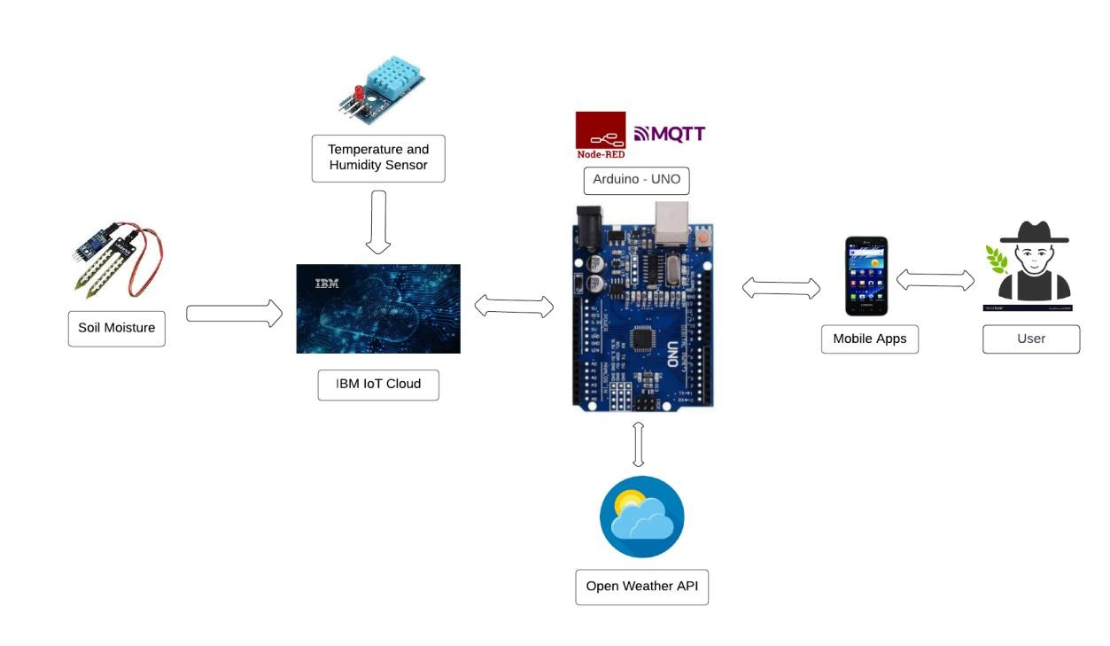

**Solution Architecture of IoT Based Smart Farming**

1. **Grid solar:** This reduces the final cost for the power utilization for the home and business. The energy generated from the sun is utilized by this panel and earns the credits which are used further.
2. **Hybrid solar:** These are used as power bank to the systems which are used for backup purpose. The power is supplied to the grid via battery bank in the event of power of outage.
3. **Off-grid solar:** These type of solar panels are independently used for a remote location and are limited.
4. Solar Panel acts as a power source and offers an opportunity to stabilize the energy cost to the farmers.

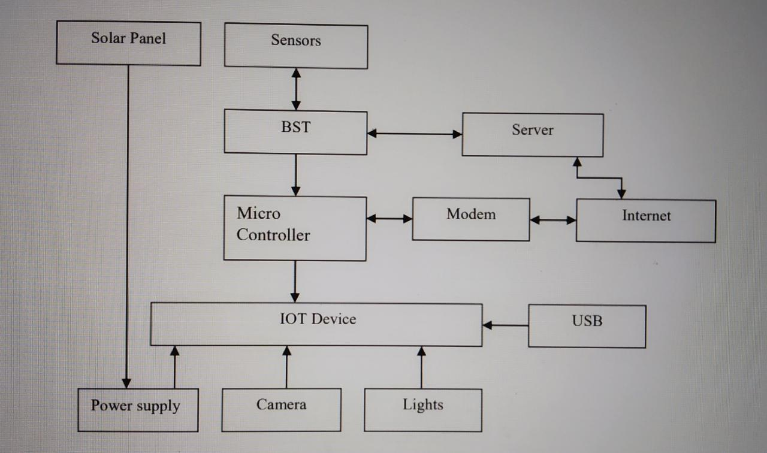

**Architecture of Smart Farming System**